Paul Fralix, 06/27/2025, Assignment 6.2

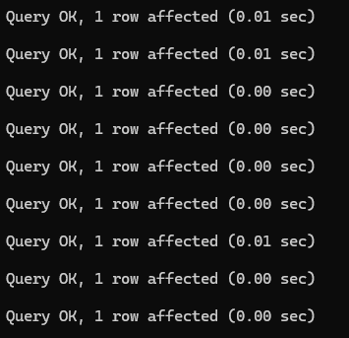

https://github.com/Peas16/csd-310.git